Australian Islamic College 2019

ATAR Chemistry Units 3 and 4

Task 15 (Weighting: 5%)

Practical Test

Test Time: 4 Periods
(3 Periods for Practical Work and 1 Period for Validation Test)

First Name | Surname
ANSWERS

Teacher

Mark / 49 41 | Percentage

Equipment allowed: Pens, pencils, erasers, whiteout, rulers and non-programmable calculators permitted by the Schools Curriculum and Standards Authority.

Before you come to class or at the start of class watch this video on YouTube.

Make Soap at Home: A Simple Olive Oil Lye Soap Tutorial. No Frills.
https://www.youtube.com/watch?reload=9&v=o04lrvf1qnE

Section One: Practical Work [8 marks]

You are going to make soap.

Materials per group of 2 students
- 300 mL vegetable oil.
- 84.5 g distilled or deionised water (dH₂O)
- 33.7 g of NaOH
- 1 electric hot plate
- Clean beakers
  - 1 x glass or plastic 1000 mL
  - 2 x glass 500 mL
  - 1 x glass 250 mL
  - 2 x glass 100 mL
- 1 x disposable 1 mL plastic pipette
- 1 x glass stirring rod
- Large kitchen spoon e.g. tablespoon
- 1 x plastic spatula or clean plastic teaspoon
- Electronic or triple beam balances – these may need to be shared
- 2 x long 0-100 ºC thermometers
- Kitchen whisk – three to be shared between all groups
- 3 disposable food containers with lids – Coles 300 mL ‘Cook and Dine Food Containers’
- Paper towels
- 2 x elastic bands
- 500 mL plastic beaker with 150 mL ice in the bottom
- Washup materials – detergent and paper towels.
- Access to fume hood if required
- 1 x permanent marker
- Lab coats, gloves and safety glasses

Safety
During this practical you must wear lab coats, gloves and safety glasses. Ensure that you know the location of the emergency eye wash and how to use it.

Procedure
- Put on a lab coat, safety glasses and gloves.
- Rinse a 200 mL glass beaker with a very small amount of distilled or deionised water (dH₂O).
- Use an electronic balance or triple beam balance to add 84.5 g of dH₂O to the 200 mL glass beaker.
- Weigh out in a separate container e.g. a clean dry 100 mL glass beaker 33.7 g anhydrous NaOH. Slowly add the NaOH to the dH₂O while continuously stirring slowly with a glass stirring rod. Add the NaOH to the dH₂O, not the water to the NaOH, otherwise heat may cause the NaOH to dangerously ‘spit’. Do not stir with the thermometer. Continue to stir until all NaOH is dissolved. Fumes may be produced during this process. Avoid breathing the fumes. Use a fumehood if the fumes become problematic. The NaOH solution is dangerous and will get hot. Place a thermometer in the NaOH solution and monitor the temperature. The NaOH solution should be used when it has cooled to about 43 ºC.
- Weigh into a clean 500 mL glass beaker about 421 g (or about 280 mL) of vegetable oil. Place the beaker on a hot plate and place a thermometer in the oil. Heat the oil until it reaches about 54 ºC. Be careful not to overheat the oil because it will take a long time to cool down.
- When both the oil and the NaOH solution are at about the correct temperature, add the oil to a clean plastic 1000 mL beaker. Add the NaOH solution. Stir the resulting mixture with a plastic spatula or spoon (not an aluminium spatula) for 5 minutes.
- Agitate the mixture with a kitchen whisk on low speed for about 5 minutes, until the mixture noticeably thickens.
- Pour the soap mixture into 2 or 3 small plastic food containers and put the lids on. Wrap the food containers in about 5 layers of paper towels and put 1 or 2 elastic bands around to hold the paper towels in place. Put your names on them and leave them for your teacher to check.
- Clean up your work area and return all equipment.
- Show your soap and your cleaned work area to your teacher.
Optional
- Leave your soap wrapped up for 24 hours to set.
- Remove your soap from the moulds and allow it to air-dry for three weeks.

Marks for Section One
- Makes at least one bar of soap [up to 3 marks]
- Evidence of carefully following instructions [up to 3 marks]
- Evidence of remaining conscious of safety at all times
and absence of misbehavior or unsafe behavior [up to 2 marks]

End of Section One
Name ____________________________________________
Section Two: Validation Test [41 33 marks]

- Triglycerides from animals are generally referred to as ‘fat’ and are solid at room temperature whereas triglycerides from plants are generally called oils and are liquid at room temperature. The difference in melting points of fats and oils can be explained in terms of the structure of the fatty acids that form the triglycerides.

  - Read through all these instructions before answering this question.
You are to draw the following two molecules. The drawings are to illustrate the difference between fatty acids from animal fats and plant oils.

- Draw a fatty acid containing 10 carbon atoms that shows the typical structure of an animal fatty acid.
- Below the first drawing, draw another fatty acid, also containing 10 carbon atoms, that shows the typical structure of a plant fatty acid.
Draw ALL atoms and ALL covalent bonds in both your drawings.
[3 marks]
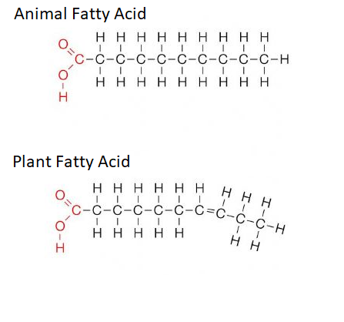
1 mark for each fatty acid = 2 marks. No half marks.
1 mark for all double bonds in ‘cis’ configuration.
Note that the plant fatty acid must have at least one double bond; multiple double bonds is OK. Double bond/s can be in any position.

  - Refer to the molecule of a typical animal fatty acid that you drew in part (a) of this question. List all types of intermolecular forces that may be present between molecules of this substance. List them in order of decreasing strength.
[1 mark; no half marks]
Hydrogen bonds.
Dipole-dipole forces.
Dispersion / London forces.
Order must be correct; no part marks. No follow-on marks.

  - Identify by its / their correct name the functional group/s involved in producing the strongest of the intermolecular forces identified in part (b) above.
[1 mark]

Carboxyl / Carboxylate / Carboxylic acid.

  - Draw a diagram to show exactly where the strongest intermolecular force you identified in part (b) of this question is located when it forms between two typical animal fatty acid molecules. You only need to draw the parts of the molecules involved in forming this intermolecular force.
Also label the location of the dipoles on your drawing.
[3 marks]

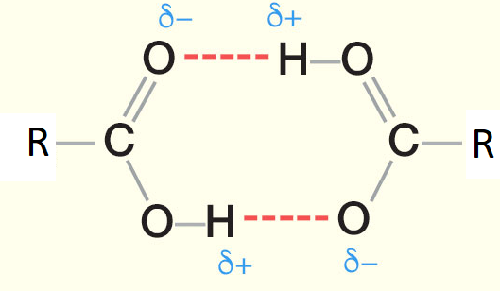
Dashed lines show hydrogen bonds.
1 mark for each hydrogen bond = 2 marks.
1 mark for all dipoles.
No part marks, no follow-on marks.

  - Refer again back to your answer to part (a) of this question.
Compare and contrast (list the differences and similarities between) the type and strength of intermolecular forces present in the two molecules you drew for your answer to part (a) of this molecule question.
Each similarity must be stated within a single, separate sentence.
Each difference must be stated within a single, separate sentence.
[4 marks]

Both molecules have hydrogen bonding / can form two hydrogen bonds per molecule / the strength of hydrogen bonding is the same.
Both molecules are capable of forming dipole-dipole forces / the strength of dipole-dipole forces is the same.
Both molecules have dispersion forces.
The plant / unsaturated fatty acid has weaker dispersion forces (because of the cis double bond/s it has bends that prevent close packing).
1 mark each. No half marks, no follow-on marks.

- Without using any ingredients other than plant triglycerides, sodium hydroxide and water, describe one way that you could make a soap with a higher melting point than you did today.
Explain why the change you suggested would work to increase the soap’s melting point.
[2 marks]

Various answers may be acceptable at the teacher’s discretion.
1 mark for change, 1 mark for explanation.
e.g. Use triglycerides with a higher molar mass to increase dispersion forces, use monounsaturated rather than polyunsaturated vegetable oil / triglycerides containing fatty acids with few double bonds to increase dispersion forces etc.

- After making soap at home, especially if it is your first time doing so, it is a good idea to check the pH of your soap before using it.
  - If the soap is made correctly, should the pH of the soap be slightly below 7, slightly above 7, or 7?
[1 mark]
Slightly above 7.

  - Why is soap that has been made properly normally the pH you identified in part (a) of this question?
[1 mark]

Soap molecules are conjugate bases of weak acids.
No follow-on marks.

  - Suppose you checked your soap and found it had a pH of 11.
    - Should you use this soap? Why?
[1 mark]

No, the soap will be caustic / will burn your skin / eyes.
No follow-on marks, no marks for ‘no’ without a valid reason.

    - What was most likely wrong with the soap ‘recipe’ if this happened?
[1 mark]

NaOH was in excess / There was insufficient vegetable oil.

- Using ethanoic acid and propanoic acid as examples, explain why not all carboxylic acids are fatty acids. Include a definition of fatty acids in your answer.
[3 marks]

A fatty acid is a carboxylic acid at least 3 carbons long (1).
Ethanoic acid is not a fatty acid because it is too short / only has two carbons (1).
Propanoic acid is a fatty acid because it is long enough / has enough carbons (1).

- Sally is a believer in living an alternative, healthy lifestyle. As such she only eats food bought from the organic food store.
Sally also believes that only ‘pure’ substances should be allowed to touch her skin.
She was recently horrified when a chemist friend told her that soap is not a pure substance, but a mixture, because the vegetable oils used to make her soap are actually a mixture of different triglycerides.
Determined to only use ‘pure’ soap, Sally pays a large amount of money to have her soap made from pure tristearin, a triglyceride containing three identical fatty acids.
In the Chemistry sense of the word, is Sally’s expensive soap a ‘pure’ substance now? Explain why or why not. Do not consider any water present in the soap and assume that during the soap-making process reactants were added in their stoichiometric ratios.
[2 marks]
No it is not pure / the soap is a mixture (1).
Because it contains salts of fatty acids (sodium stearate) and glycerol (glycerol must be named for this mark) (1).

- Draw the triglyceride that you would use to form soap molecules with the structure CH₃(CH₂)₇CH=CH(CH₂)COO⁻ Na⁺.
You may used condensed structural formulae in your answer.
[2 marks]
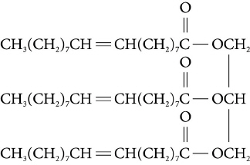

1 mark off per mistake.

Note: There was a mistake in this question. The formula of the soap molecule should have been CH₃(CH₂)₇CH=CH(CH₂)₇COO⁻ Na⁺. Therefore be flexible when marking students’ answers to allow for this.

- The following diagram shows a structure that is formed during the cleaning action of soap.
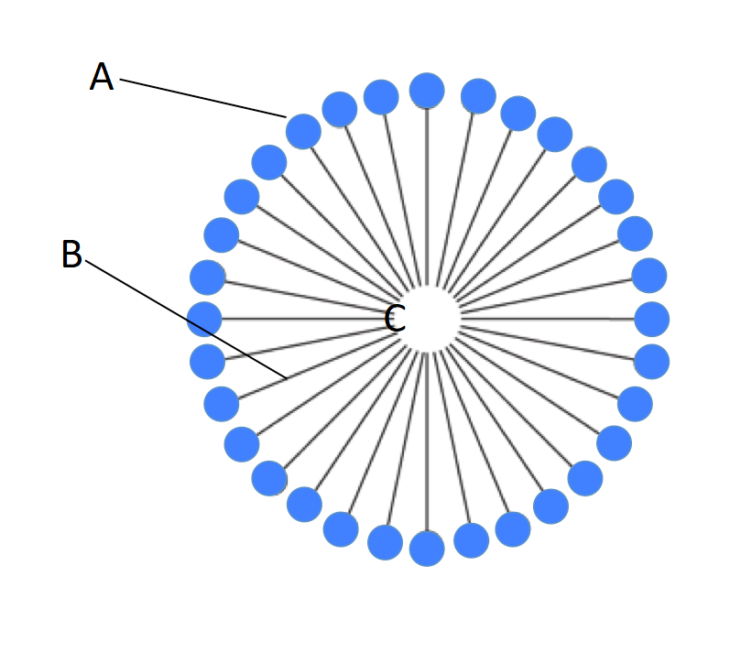

  - Name the structure shown above (the entire structure).
[1 mark]

Micelle

  - Identify the part of the soap molecule labelled ‘A’ as being hydrophobic or hydrophilic and explain what is meant by this.
[1 mark]

Hydrophilic, which means ‘water loving’ / attracted to water (1).
No half marks.

  - During the normal cleaning action of soap structure A is attracted by hydrogen bonding to what important solvent?
[1 mark]
Water

  - Identify the part of the soap molecule labelled B as being polar or non-polar.
[1 mark]

Non-polar

  - Name the two atoms that would predominate in the part of the soap molecule labelled B.
[1 mark]

Carbon and hydrogen. 1 mark for both; no part marks.

  - Identify the predominant intermolecular force operating between the soap molecule and ‘grease’ or ‘dirt’ at location C.
[1 mark]
Dispersion / London forces.

- Explain in words AND with a suitable balanced, ionic equation with state symbols why soaps do not work in water containing calcium ions.
[2 marks]

Soap molecules react with calcium ions to form an insoluble scum / precipitate (1).

Ca²⁺_{(aq)} + 2CH₃(CH₂)₁₆COO⁻_{(aq)} → Ca(CH₃(CH₂)₁₆COO)_{2(s)} (1)

OK to use any soap molecule as an example. Also OK to use R to represent the hydrocarbon chain.

No half marks. Equation must be balanced and have correct state
symbols.

This question was excluded from the test.

- Biodiesel can be produced by a trans-esterification reaction between vegetable oil and an alcohol in the presence of sodium hydroxide catalyst. A typical trans-esterification reaction is shown below. The products are glycerol and three methyl esters.

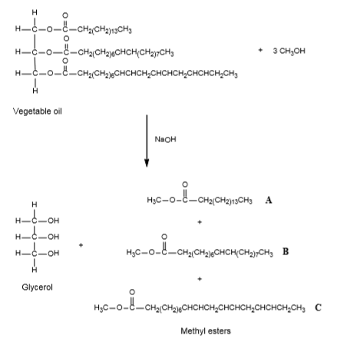

  - Explain the purpose and mechanism of action of the NaOH catalyst in the above reaction.
[3 marks]
The catalyst increases reaction rate (1)
By providing an alternative reaction pathway (1)
With a lower activation energy (1)

  - Name and explain the undesirable side reaction that may occur during the production of biodiesel shown above. Show this reaction using molecule A as your example. Also explain how that side reaction is minimised.
[4 marks]
Saponification (1)
The NaOH reacts with the triglyceride or the biodiesel producing soap (1)
CH₃(CH₂)₁₃CH₂COOCH₃ + NaOH ← → CH₃(CH₂)₁₃CH₂COO⁻⁺Na + CH₃OH (1)
Minimised by the use of lipase / removal of water from the mixture (1)

  - Name the functional group in glycerol.
[1 mark]
Hydroxyl (accept alcohol) (1)

